Technical Competency

Deepak

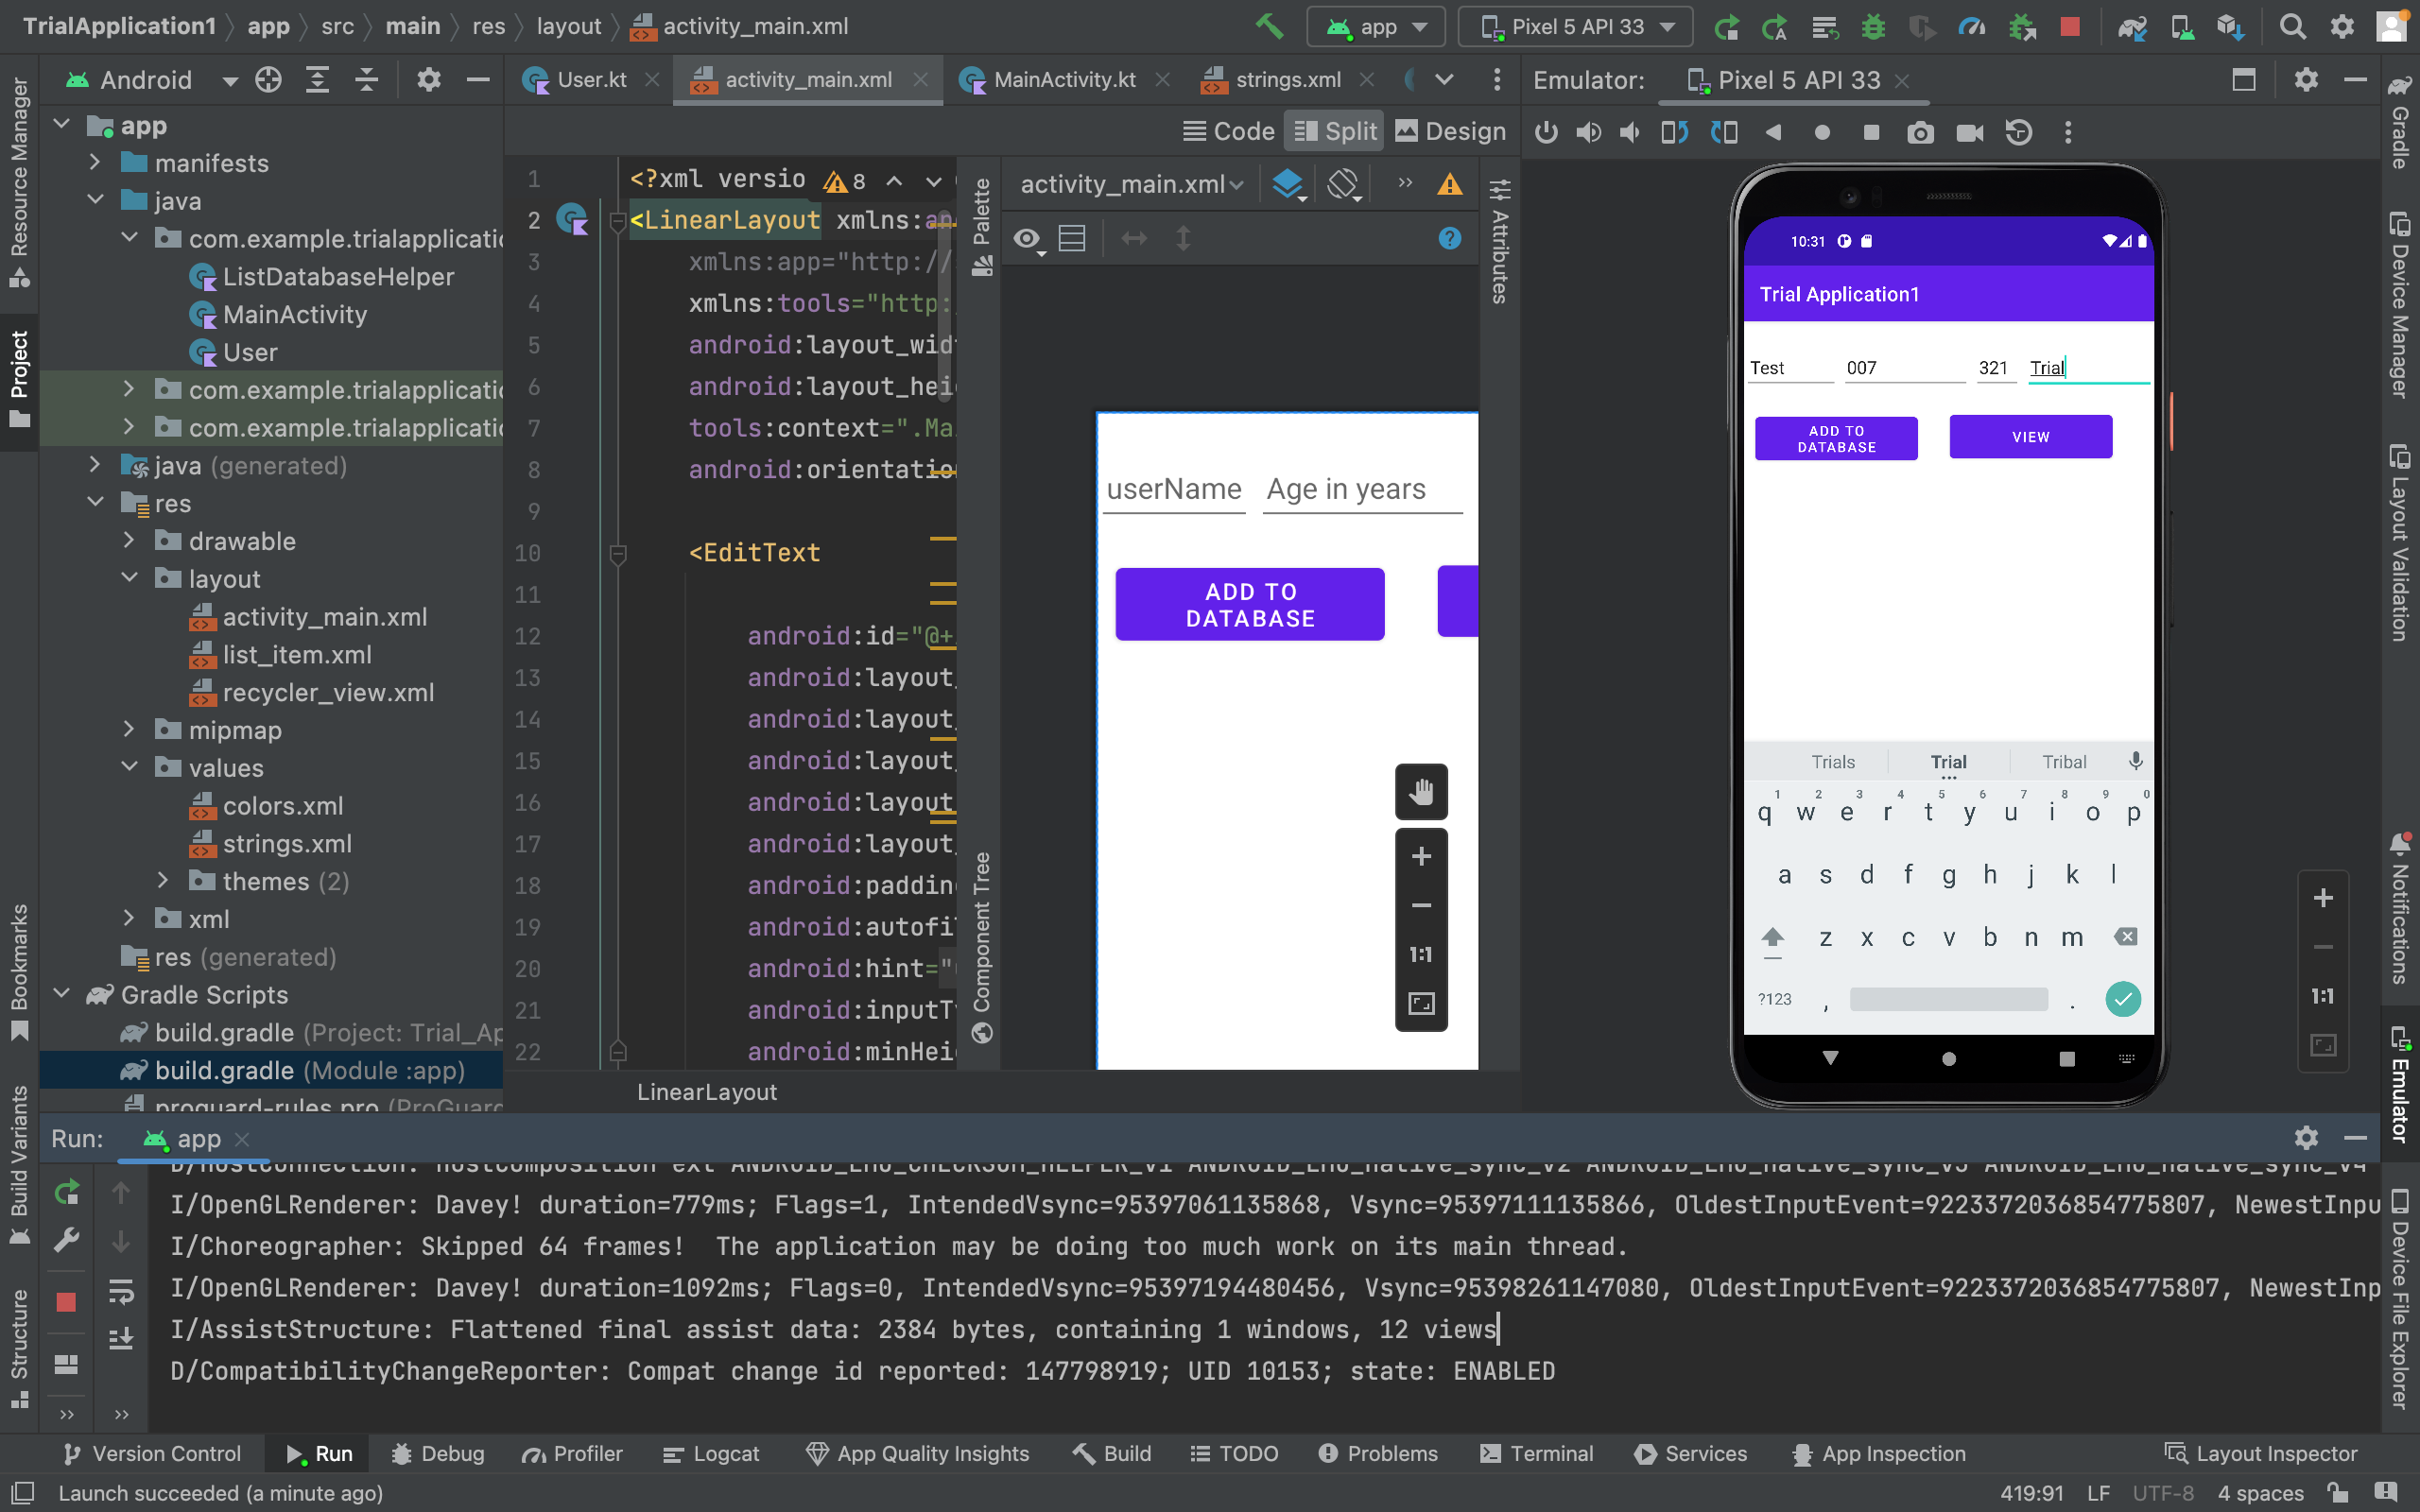

Entering data to be stored in the Sqlite database

4 fields to be stored

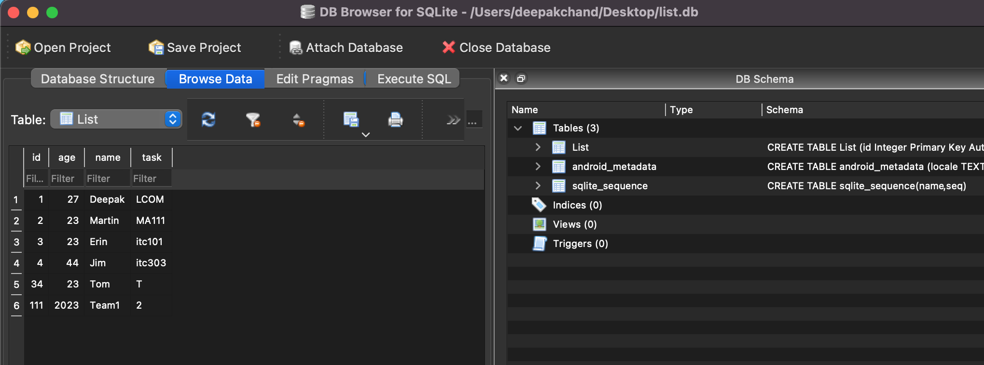

Data gets stored in the database.